PARISH COUNCIL MTG: Mells September 2026

Number of Crimes by Offence Type

No crimes to report for the month of September

Violence Against the Person
Please note: ‘Violence Against a Person’ is a broad classification encompassing various incidents. These can range from physical altercations, such as one person striking another, to verbal disputes where someone shouts, causing another person to feel unsafe. It also includes situations where body language suggests intent to harm, as well as instances where an individual perceives a potential threat—perhaps due to a mental health episode

Number of Crimes Trend:

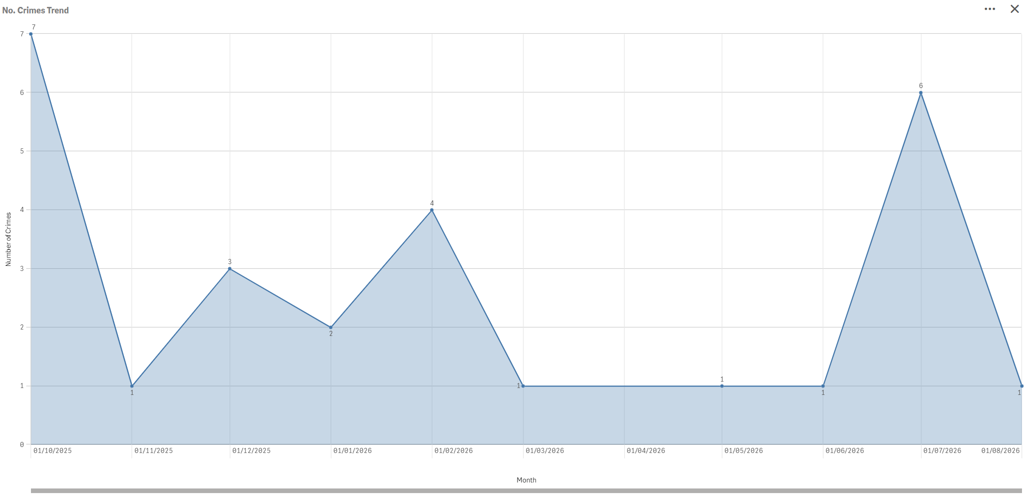

CURRENT PACT PRIORITIES:

Maintain a visible Police presence in Mells alongside monthly beat Surgeries in Mells which we are currently looking for a new venue.

FUTURE PACT PRIORITIES:

Regular foot patrols are ongoing and productive community engagement.
Please remember to report Anti-Social-Behaviour and drug related incidents to 101 or 999, respectively.

OVERALL CRIME TRENDS

None of significant not

We have moved to a new Community Alerts system and to continue to receive Horse and Farm Watch alerts, you need to Register for Community Alerts on our new system. Please do not use the previous portal, as this is going to be turned off.

Registering
· Follow the instructions on https://www.avonandsomerset.police.uk/apply/community-alerts/registration/ to register your account
o You will not be required to set a password on the new system, so if you have been asked to set one then you need to go to: https://www.community-alerts.policedigital.services/SelfService/Login instead

Unsubscribing
· If you have not yet registered on the new system, you do not need to do anything and can ignore any messages received.
· If you have already registered on our new system, you can delete your account through your account summary. You will then no longer receive alerts.

